**Loktak Lake**

**Loktak Lake** is the largest natural freshwater lake in [India](https://wii.gov.in/nwdc_ramsar_wetland_sites).[]](https://en.wikipedia.org/wiki/Loktak_Lake#cite_note-2) It is a pulsating lake, with surface area varying from 250 sq km to 500 sq km during rainy season with a typical area of 287 sq km. The lake is located at [Moirang](https://en.wikipedia.org/wiki/Moirang" \o "Moirang) in [Manipur](https://en.wikipedia.org/wiki/Manipur) state, India.[]](https://en.wikipedia.org/wiki/Loktak_Lake#cite_note-wet-4) The [etymology](https://en.wikipedia.org/wiki/Etymology) of *Loktak* is *Lok* = "stream" and *tak* = "the end".It is famous for the phumdis (heterogeneous mass of vegetation, soil and organic matter at various stages of decomposition) floating over it.

Loktak Day is observed every year on the 15th of October at the periphery of the Loktak lake.

This ancient lake plays an important role in the economy of [Manipur](https://en.wikipedia.org/wiki/Manipur). It serves as a source of water for [hydropower](https://en.wikipedia.org/wiki/Hydropower) generation, irrigation and drinking water supply. The lake is also a source of livelihood for the rural fishermen who live in the surrounding areas and on phumdis, also known as "phumshongs". Human activity has led to severe pressure on the lake ecosystem. 55 rural and urban hamlets around the lake have a population of about 100,000 people.

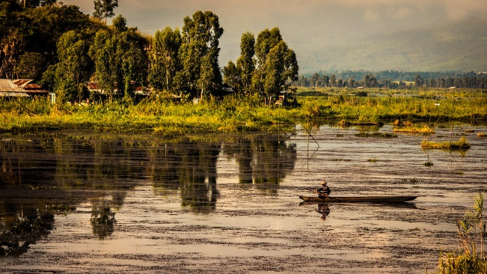

2nd photo:

<https://www.google.com/search?q=loktak+lake&rlz=1C1CHBD_enIN932IN932&sxsrf=AOaemvLLHjQVHgGGDctaDPRRMcpwXB4x5Q:1633003921352&source=lnms&tbm=isch&sa=X&ved=2ahUKEwi8iJjV1abzAhVOwTgGHRoiB0sQ_AUoAXoECAEQAw&biw=1536&bih=696&dpr=1.25#imgrc=9lgZa9l1MHAHNM>

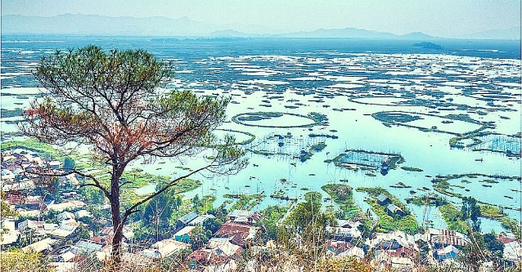

1st photo:

<https://www.google.com/search?q=loktak+lake&rlz=1C1CHBD_enIN932IN932&sxsrf=AOaemvLLHjQVHgGGDctaDPRRMcpwXB4x5Q:1633003921352&source=lnms&tbm=isch&sa=X&ved=2ahUKEwi8iJjV1abzAhVOwTgGHRoiB0sQ_AUoAXoECAEQAw&biw=1536&bih=696&dpr=1.25#imgrc=DxZbhn9lTiRk0M>

Vlog:

<https://youtu.be/zIsZLKHHN7Q>